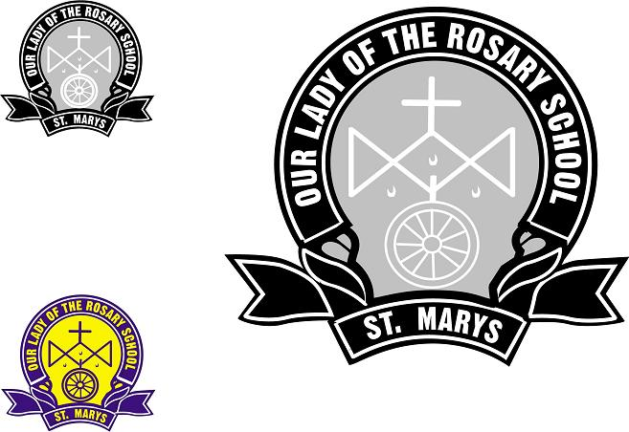 | Our Lady of the Rosary  32b Saddington Street, St Marys NSW 2760  PO Box 811, St Marys 1790  Phone: 9623 2500 Fax: 9623 2597  Email: olorstmarys@parra.catholic.edu.au  Website: www.olorstmarys.catholic.edu.au

CHANGE OF FAMILY DETAILS

ONLY COMPLETE DETAILS THAT HAVE CHANGED

SURNAME ……………..………. CHILD’S NAME ……………….…CLASS……

ADDRESS………………………………………………………………………………………

……………………………………………………………POSTCODE………………………..

HOME PHONE ……………………………………………..

FATHER’S WORK PHONE………………………………….….FATHER’SMOBILE……………………………

MOTHER’S WORK PHONE………………………………….…MOTHER’SMOBILE…………………………....

EMERGENCY CONTACT DETAILS DURING SCHOOL HOURS OTHER THAN ABOVE

NAME: …………………………………… PHONE NO………………………

RELATIONSHIP TO CHILD …………………………………………………

SIGNATURE …………………………………………….DATE……………………………

NAME (Please print) …………………………………………….

OFFICE USE ONLY - PLEASE INITIAL

COMPUTER
OFFICE
PRINCIPAL
ASSIST PRINCIPAL
STAFFROOM
SPECIAL ED

/tmp/in/input.doc

