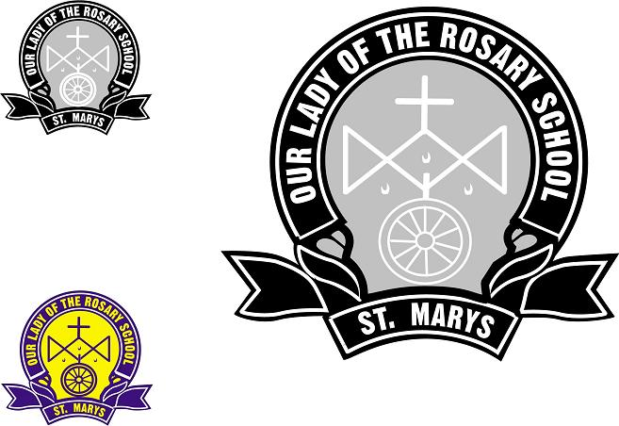 | Our Lady of the Rosary  32b Saddington Street, St Marys NSW 2760  PO Box 811, St Marys 1790  Phone: 9623 2500 Fax: 9623 2597  Email: olorstmarys@parra.catholic.edu.au  Website: www.olorstmarys.catholic.edu.au

Excursion Permission Note and Medical Notification

EXCURSION: _______________________________________________________

DATE: _____________________________________________________

COST: _____________________________________________________

I understand that my child will be travelling to and from the excursion by _______________________

- I give permission for my child __________________________________ Class_____ to attend the
- Please find enclosed $ __________.

- I DO NOT give permission from my child to participate in this excursion. (Any
comments would be gratefully and sensitively accepted.)

.........................................................................................................................................

Please list any medical conditions which the teacher should be aware of for the excursion:-
………………………………………………………………………………………………………………………………………………………………………………………………………………………………
Contact Parent on the day: ………………………………………………………………………………….
Contact Parent phone numbers: …………………………………………………………………………….
Emergency contact Name (other than the person listed above):……………………………………………
Phone Numbers: ……………………………………………………………………………………………
Medicare No: …………………………………………………
In the event of an emergency, I give teachers of Our Lady of the Rosary Primary School my permission to seek medical attention for my child and I understand that I will be notified as soon
as possible.

Parent / Guardian (Signature) …………………………………………… Date ……………………..

